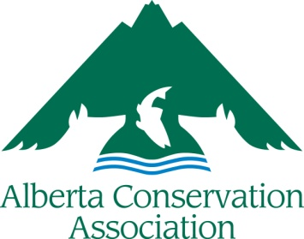
Progress Report Submission Form
2022
ACA Grants in Biodiversity

Due by April 15, 2022
Please review the accompanying Instructions prior to completing this form.

Project Title
Recipient
Supervisor(s)
Institution

Questions:

- Are you on track time-wise with your project? YES or NO? If NO, please explain briefly:
- Is your budget being spent according to the budget provided to ACA? YES or NO? If NO, please explain briefly:
- Have you published any papers or made any presentations on the project supported by ACA funds? If so, please list them below (with links, if possible).
- If applicable, provide the WMU(s) or national park where your field work took place?
- In one or two sentences, why is your project important?

Media Submissions:
Photo Captions: Please provide one or two high quality digital images resulting from your project (max 5). Please write a short caption for each of your images in the text box below. Please provide clear information on who should be credited for each image. Send pictures as separate files as outlined in the Instructions, not inserted into this report document.

File Name | Caption

Permission to use photos:

I confirm that I am the owner of and/or have the legal right to share the media I am providing. I hereby give ACA permission to use the media I am providing to represent my work in ACA’s grant publications and grant-related media. I also give ACA permission to produce, reproduce, publish, display, distribute, edit, print, trade, or share in publications, posters, exhibits, films, video presentations, audio/video presentations, news releases, advertisements, on social media, and all other digital and online formats in perpetuity. And I hereby irrevocably waive all rights I may have to the media and the content of the media, including the right to any compensation and the right to inspect or approve of any use, reproduction, display or distribution by ACA in perpetuity.

