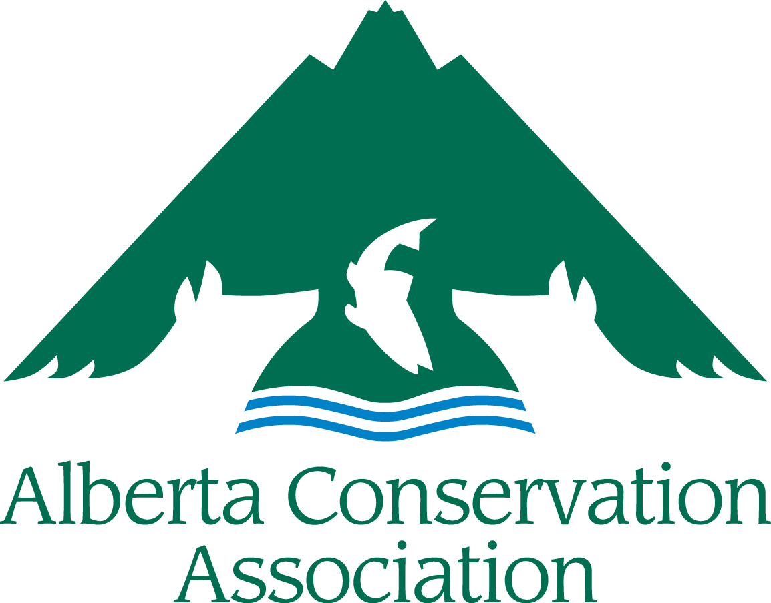
ACA Research Grants
Application Form
2023 – 2024

Please submit your digital application to amy.mackinven@ab-conservation.com
Applications accepted from November 1st to December 1st, 2022
(NO later than 16:30 local time Thursday, December 1st, 2022)

INCOMPLETE APPLICATIONS WILL BE RETURNED TO THE APPLICANT. ALL SECTIONS MUST BE FILLED IN.

Hard copies also accepted:
Alberta Conservation Association
#101, 9 Chippewa Rd,
Sherwood Park, AB,
Canada, T8A 6J7
Toll Free: 1.877.722.4323
Facsimile: 780.464.0990

Maximum page limit of 14 pages for ACA Research Grant applications (excluding the cover page and FOIPP page, please use a legible font size, i.e., nothing smaller than Arial 11)
APPLICANT INFORMATION
Principal Investigators Name
Organization
Mailing Address
Email Address
Telephone Number
Project Manager/Co-applicants
(if different than applicant)
Not-for-profit Business Number (if applicable)
PROJECT INFORMATION
Project Title
Project Location
(please append map, if available)
Project Duration | Start date (dd/mm/yyyy) |  |  | End date (dd/mm/yyyy)
Project Summary (Please include a brief description of your project containing the objectives, activities and project deliverables. Maximum 250 words)

Amount Requested from ACA (in CDN $)

Has this project received financial or administrative support from the ACA in the past? (If yes, list grants and please highlight the results of the work previously supported by the ACA. How does the present funding request build on that work? Note: It is important to demonstrate evidence of progress if this is a request for repeat funding.)
Long Term Requirements (Is the project on-going? Does this project require subsequent ACA funding to reach project objectives? If applicable, explain how this project will continue after being funded by ACA.)
PROJECT DESCRIPTION
Project Background/Project Rationale:
Project Objectives: (Clearly state the specific objectives and hypothesis(es) to be tested.)

Activities/Methodology:
References (references cited in background, methodology):
Deliverables (List anticipated products and completion dates resulting from your project, including reports, videos, open-access journal publications, promotional material, # of people reached etc.):
List Project Staff (Please list all project staff and students):
List Project Partners (Partners must be aware they are mentioned here):
LINK WITH ACA
State how this project meets the ACA Mission and the Funding Priorities as outlined in Section 3 of the Project Submission Guidelines (Please use the Funding Priority number to make it clear):
Explain how your project will benefit hunters, anglers, or trappers in Alberta (Maximum of 250 words):

DETAILED BUDGET
Category | Description | Amount Requested From ACA | Confirmed Partner Funding | In Kind Support | Total
Materials & Supplies
Equipment
Salaries & Wages
Contract Services
Travel
Honorariums
Capital Assets
Open Access Publication Costs
Other
TOTAL COSTS
Capital Assets are items>$500 that can be reused on other projects. Capital equipment purchases may remain the property of ACA upon project completion.
Please Note: the ACA Research Grants do not cover overhead costs. Academic projects must ensure that the overhead waiver has been or can be obtained. See Guidelines Section 4 Budget Notes for more information.

PROJECT BUDGET COMMENTARY
BUDGET COMMENTARY:
Provide details on capital expenditures >$500 and provide breakdown of salary costs (number of staff, rates, etc.). Include other details that may assist with the evaluation of your budget.
Summarize any Partner Funding Dollars (Please indicate if the partner funds are confirmed or pending approval. Confirmed partner funds should be listed in the budget. If there is no partner funding, please explain why not.):
Summarize any Public Involvement in the Project (Such as In-kind support, number of volunteers, etc.):
PROJECT COMMUNICATION
How will ACA be recognized for its funding support?
How will you share the results of the project with others?

Does your organization have a web page? YES NO
If yes, will you create a reciprocal link with the ACA website? YES NO
URL

PROJECT REVIEW
Research applications are subject to an academic review procedure. Please provide the Name, mailing address, and email of four possible referees. (Please refer to the Guidelines Section 4 Project Review).

LICENSES & APPROVALS
I have all the proper licenses and approvals required to carry out the project and have complied with all the requirements of my organization. YES NO

If you ticked NO above, please explain how will you obtain them in time to carry out this project?

Please Note: Successful applicants will be expected to follow the ACA Cooperative Project Agreement which for 2023/24 includes a clause relating to the COVID-19 pandemic. In applying to the ACA Research Grants, you are agreeing to use ACA’s Cooperative Project Agreement. A copy of the ACA Cooperative Project Agreement can be requested from the ACA Grants Coordinator.

FREEDOM OF INFORMATION
& PROTECTION OF PRIVACY (FOIPP) ACT

The personal information required on the ACA Research Grants Application Form is collected under the authority of Wildlife Regulation AR 143/97, Section 2 (2.1) and section 39(4) of the Freedom of Information and Protection of Privacy (FOIPP) Act to administer the ACA Research Grant program, and will be used for the purposes of determining eligibility in the ACA Research Grants competition. This information is protected by the privacy provisions of the Alberta FOIPP Act. Questions about the collection or use of this information should be directed to the Alberta Conservation Association FOIPP Coordinator, 101, 9 Chippewa Road, Sherwood Park, Alberta, T8A 6J7 or phone 780-410-1999.
Notice: The ACA Research Grants program relating to the grant adjudication process in the annually competition for awards stipulates that referees will provide a confidential evaluation of the research proposed in this application. In signing this form you are agreeing to waive your right to see the evaluations or referees’ comments, as provided in Section 19(1) of the Freedom of Information and Protection of Privacy Act. A synopsis of the comments on the referee’s evaluation MAY be disclosed, provided that such disclosure is compliant with Division 3, Section 30(4c) of the Act, whereby the third party (reviewer) agrees to the disclosure. Please note that successful applicants will be required to submit reports as per of the Cooperative Project Agreement. This material may be published in Annual Summary Report and on the ACA web pages and in promotional material for the ACA Grant Programs (posters, brochures, etc.).

Signature of applicant | Date
Printed or typewritten name | Institution

