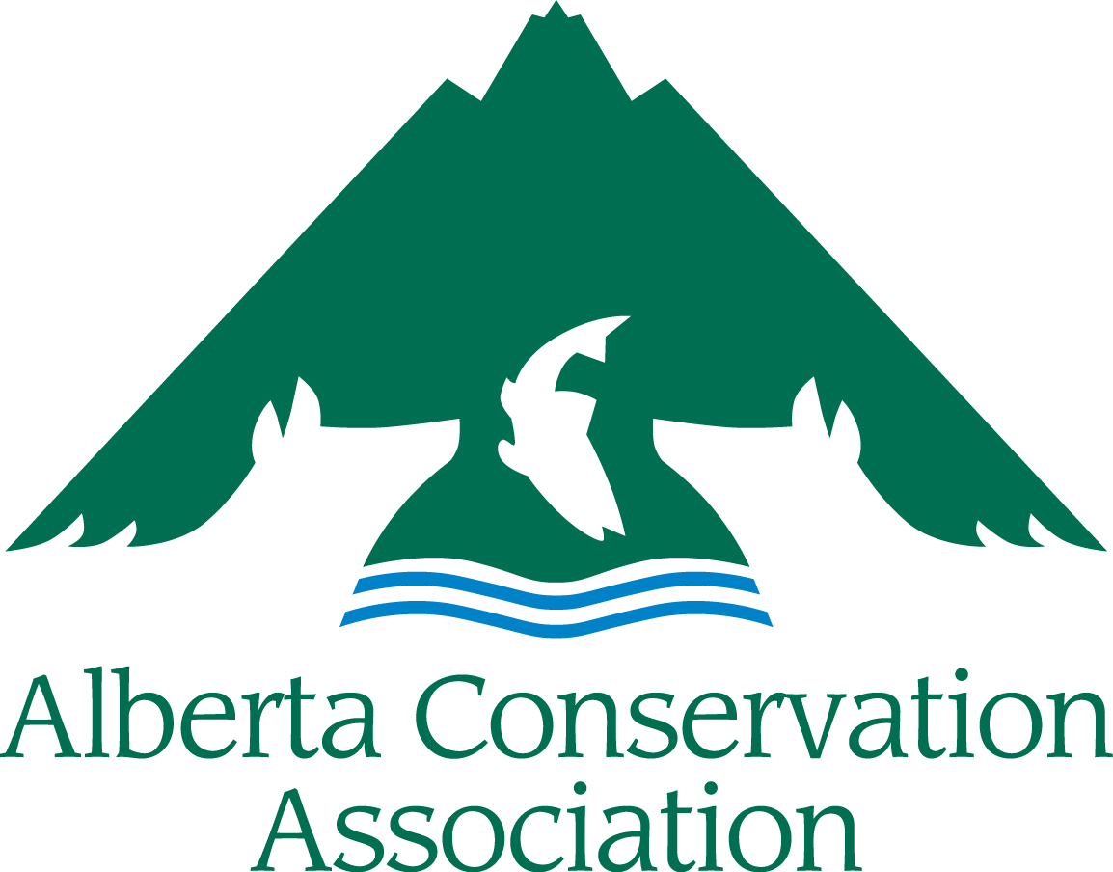
ACA Conservation, Community,
and Education Grants
Application Form
2024 – 2025

Large Grant
(for requests of over $3,000)

BEFORE YOU SUBMIT, PLEASE MAKE SURE:
- You read the ACA CCEG Project Submission Guidelines for 2024-25
- Your application is complete. Incomplete applications will be returned to the applicant. All sections must be filled in.
- Your application is NOT longer than the 8-page limit (excluding the cover page). Applications over the page limit will be returned to the applicant for reformatting.
- Your application is a legible font size (i.e., nothing smaller than Arial 10)

Please submit your digital application to amy.mackinven@ab-conservation.com
Applications accepted from January 1st to 25, 2024
(NO later than 16:30 local time Wednesday, January 25, 2024)

IMPORTANT NOTICE: upon receiving your application, we will send you an acknowledgment receipt by e-mail or telephone within five business days. It is your responsibility to contact the ACA Grants Coordinator if you have not received acknowledgement of receipt, as the application may not have been received in good order.

APPLICANT INFORMATION
Principal Applicants Name
Organization
Mailing Address
Email Address
Telephone Number
Project Manager/Co-applicants
(if different than applicant)
Not-for-profit Business Number (if applicable)
PROJECT INFORMATION
Project Title
Project Location
(please append map, if available)
Project Duration | Start date dd/mm/yyyy |  | End date dd/mm/yyyy
Project Summary (Please include a brief description of your project containing the objectives, activities, and project deliverables. Maximum 250 words)

Amount Requested from ACA (in CDN Dollars)

Has this project received financial or administrative support from ACA in the past? (If yes, list grants & please highlight the results of the work previously supported by ACA. How does the present funding request build on that work? Note: It is important to demonstrate evidence of progress if this is a request for repeat funding.)
Long Term Requirements (Is the project on-going? Does this project require subsequent ACA funding to reach project objectives? If applicable, explain how this project will continue after being funded by ACA.)

PROJECT DESCRIPTION
Project Background/Project Rationale:

Project Objectives: (Clearly state the project’s specific objectives, i.e. what is your project trying to achieve?)

Project Activities (How and when are you going to achieve the above objectives?):

Deliverables: (List anticipated products and completion dates resulting from your project, including reports, videos, publications, structures built, promotional material, # of events with dates and locations, # of educated participants/campers, # of people reached, km of wildlife friendly fencing, ha sustainably managed, etc.).
Type of Deliverable | Description of deliverable | Estimated # of participants or people reached or # of kms / ha (if applicable) | Estimated Date of Completion
Any additional information about the project’s deliverables:

List Project Partners (Project Partners must be aware they are listed here and be involved with this specific project. Do not include organization partners if they are not involved with the project):

LINK WITH ACA
State how this project meets ACA’s Mission and the Funding Priorities as outlined in Section 3 of the Project Submission Guidelines. Tick all the Funding Priorities that your project addresses and discuss in the text box below how your proposed project helps further ACA’s mission and Funding Priorities:

Funding Priority 1 ☐ Funding Priority 4 ☐
Funding Priority 2 ☐ Funding Priority 5 ☐
Funding Priority 3 ☐ Funding Priority 6 ☐

Explain how your project will benefit hunters, anglers, or trappers in Alberta (Maximum of 250 words)

BUDGET
Category | Description | Amount Requested From ACA | Confirmed Partner Funding | In Kind Support | Total
Materials & Supplies
Equipment
Salaries & Wages
Contract Services
Travel
Honorariums
Capital Assets
Other
TOTAL COSTS
Capital Assets are items>$500 that can be reused on other projects. Capital equipment purchases may remain the property of ACA upon project completion.
Please Note: ACA Grants do not cover overhead costs. See Guidelines Section 4 Budget Notes for more information.

PROJECT BUDGET COMMENTARY

BUDGET COMMENTARY:
Provide details on capital asset expenditures >$500 and provide breakdown of salary costs/honoraria (number of staff, rate, etc.), equipment (unit cost, etc). Include other details that may assist with the evaluation of your budget. You don’t need to send quotes.

Summarize any Partner Funding Dollars (Please indicate if the partner funds are confirmed or pending approval. Confirmed partner funding should be listed in the budget. If there is no partner funding, please explain why not.):

Please list financial contributions by participants if applicable (If this application is for a camp or another type of event that people attend, please provide estimated number of participants and how much they are paying to attend the camp, workshop, or other event? Also indicate if the camp, workshop, or other event is free to participants?) If participants are paying to attend, these amounts should be in the Partner Funding column.

Summarize any Public Involvement in the Project (Such as In-kind support, number of volunteers, etc.):

PROJECT COMMUNICATION
How will ACA be recognized for its funding support?

How will you share the results of the project with others?

Does your organization have a web page? YES ☐ NO ☐
(If yes, will you create a reciprocal link with ACA’s website?) YES ☐ NO ☐
URL

LICENSES & APPROVALS
I have all the proper licenses and approvals required to carry out the project and have complied with all the requirements of my organization. YES ☐ NO ☐

If you ticked NO above, please explain how will you obtain them in time to carry out this project?

Please Note: Successful applicants will be expected to follow the ACA Cooperative Project Agreement. In applying to the ACA Conservation, Community and Education Grants, you are agreeing to use ACA’s Cooperative Project Agreement. A copy of the ACA Cooperative Project Agreement can be found on ACA’s website here https://www.ab-conservation.com/grants-program/aca-conservation-community-and-education-grants/applicant-information/ .

