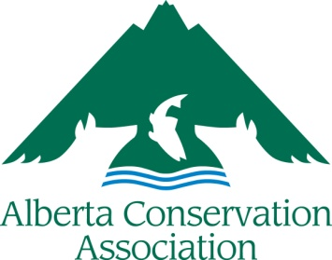
Final Scientific Report Submission Form
2022
ACA Grants in Biodiversity

Due by April 15, 2022
Please review the accompanying Instructions prior to completing this form.

Project Title
Recipient (as you would like your name to be published)
Supervisor(s)
Institution

Check if this is a first year final report

Final Project Summary:
Briefly describe your project and your findings in 150-250 words. Remember to use first person and orient your summary to a layperson audience. Expand the box as needed.

Questions:

If you have one, please provide your:
ORCiD
LinkedIn
ResearchGate

If applicable, provide the WMU(s) or national park where your field work took place?
Is there information available about your project online to which ACA could link?

Media Submissions:
Photo Captions: Please provide one or two high quality digital images resulting from your project (max 5). Please write a short caption for each of your images in the text box below. Please provide clear information on who should be credited for each image. Send pictures as separate files as outlined in the Instructions, not inserted into this report document.

File Name | Caption

Permission to use photos~:

I confirm that I am the owner of and/or have the legal right to share the media I am providing. I hereby give ACA permission to use the media I am providing to represent my work in ACA’s grant publications and grant-related media.
I also give ACA permission to produce, reproduce, publish, display, distribute, edit, print, trade, or share in publications, posters, exhibits, films, video presentations, audio/video presentations, news releases, advertisements, on social media, and all other digital and online formats in perpetuity. And I hereby irrevocably waive all rights I may have to the media and the content of the media, including the right to any compensation and the right to inspect or approve of any use, reproduction, display or distribution by ACA in perpetuity.

