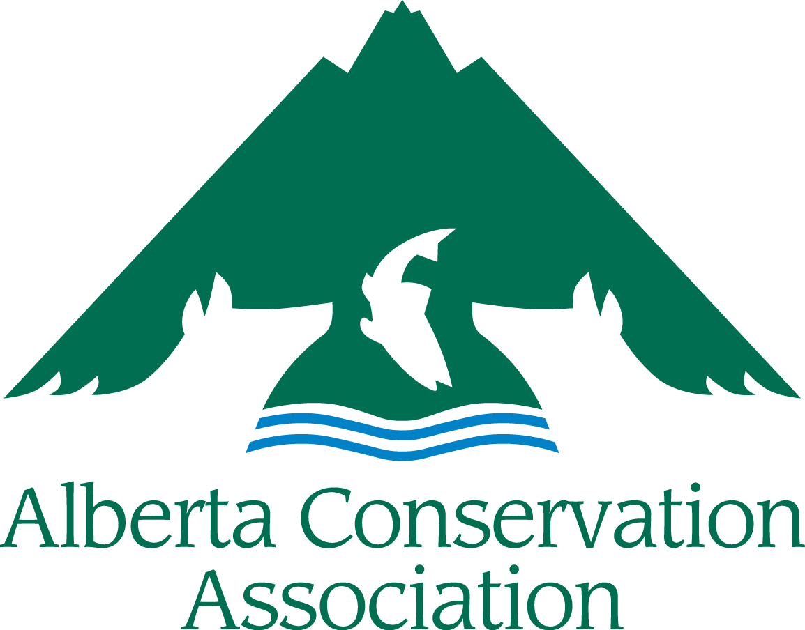
Conservation, Community and Education Grants Application Form
2020 – 2021

Large Grant
(for requests of over $3,000)

Please submit your digital application to amy.mackinven@ab-conservation.com
Applications accepted from January 1st to 24th 2020
(NO later than 16:30 local time Friday, January 24th, 2020)

INCOMPLETE APPLICATIONS WILL BE RETURNED TO THE APPLICANT. ALL SECTIONS MUST BE FILLED IN.

Hard copies also accepted:
Alberta Conservation Association
#101, 9 Chippewa Rd,
Sherwood Park, AB,
Canada, T8A 6J7
Toll Free: 1.877.722.4323
Facsimile: 780.464.0990

A maximum page limit of 8 pages has been introduced for ACA Conservation, Community and Education Grant applications (excluding the cover page, please use a legible font size, i.e. nothing smaller than Arial 9)

APPLICANT INFORMATION
Principal Applicants Name
Organization
Mailing Address
Email Address
Telephone Number
Project Manager/Co-applicants
(if different than applicant)
Not-for-profit Business Number (if applicable)
PROJECT INFORMATION
Project Title
Project Location
(please append map, if available)
Project Duration | Start date dd/mm/yyyy |  | End date dd/mm/yyyy
Project Summary (Please include a brief description of your project containing the objectives, activities and project deliverables. Maximum 250 words)

Amount Requested from ACA (in CDN Dollars)

Has this project received financial or administrative support from the ACA in the past? (If yes, list grants & please highlight the results of the work previously supported by the ACA. How does the present funding request build on that work? Note: It is important to demonstrate evidence of progress if this is a request for repeat funding.)
Long Term Requirements (Is the project on-going? Does this project require subsequent ACA funding to reach project objectives? If applicable, explain how this project will continue after being funded by ACA.)
PROJECT DESCRIPTION
Project Background/Project Rationale:
Project Objectives: (Clearly state the project’s specific objectives, i.e. what is your project trying to achieve?)

Project Activities (What are you going to do to achieve the above objectives?):
Deliverables: (List anticipated products and completion dates resulting from your project, including reports, videos, publications, structures built, promotional material, # of events with dates and locations, # of educated participants/campers, # of people reached, km of wildlife friendly fencing, ha sustainably managed, etc.).
List Project Partners (Project Partners must be aware they are listed here and be involved with this specific project. Do not include organization partners if they are not involved with the project):
LINK WITH ACA
State how this project meets the ACA Mission and the Funding Priorities as outlined in Section 3 of the Project Submission Guidelines (Please use the Funding Priority Number so it is clear):
Explain how your project will benefit hunters, anglers or trappers in Alberta (Maximum of 250 words)

DETAILED BUDGET
Category | Description | Amount Requested From ACA | Confirmed Partner Funding | In Kind Support | Total
Materials & Supplies
Equipment
Salaries & Wages
Contract Services
Travel
Honorariums
Capital Assets
Other
TOTAL COSTS
Capital Assets are items>$500 that can be reused on other projects. Capital equipment purchases may remain the property of ACA upon project completion.
Please Note: the ACA Grants do not cover overhead costs. University projects must ensure that the overhead waiver can be obtained. See Guidelines Section 4 Budget Notes for more information.

PROJECT BUDGET COMMENTARY

BUDGET COMMENTARY:
Provide details on capital asset expenditures >$500, and provide breakdown of salary costs/honoraria (number of staff, rate, etc.), equipment (unit cost, etc). Please list financial contributions by participants/campers (are participants paying something to attend the camp, workshop, or other event?); this should be shown in the Partner Funding column. Include other details that may assist with the evaluation of your budget.

Summarize any Partner Funding Dollars (Please indicate if the partner funds are confirmed or pending approval. Confirmed partner funding should be listed in the budget. If there is no partner funding, please explain why not.):

Summarize any Public Involvement in the Project (Such as In-kind support, number of volunteers, etc.):

PROJECT COMMUNICATION
How will ACA be recognized for its funding support?

How will you share the results of the project with others?

Does your organization have a web page? YES NO
(If yes, will you create a reciprocal link with the ACA website?) YES NO
URL

Please Note: Successful applicants will be expected to follow the ACA Cooperative Project Agreement. In applying to the ACA Conservation, Community and Education Grants, you are agreeing to use ACA’s Cooperative Project Agreement.
I have all the proper licenses and approvals required to carry out the project and have complied with all the requirements of my organization. YES NO

