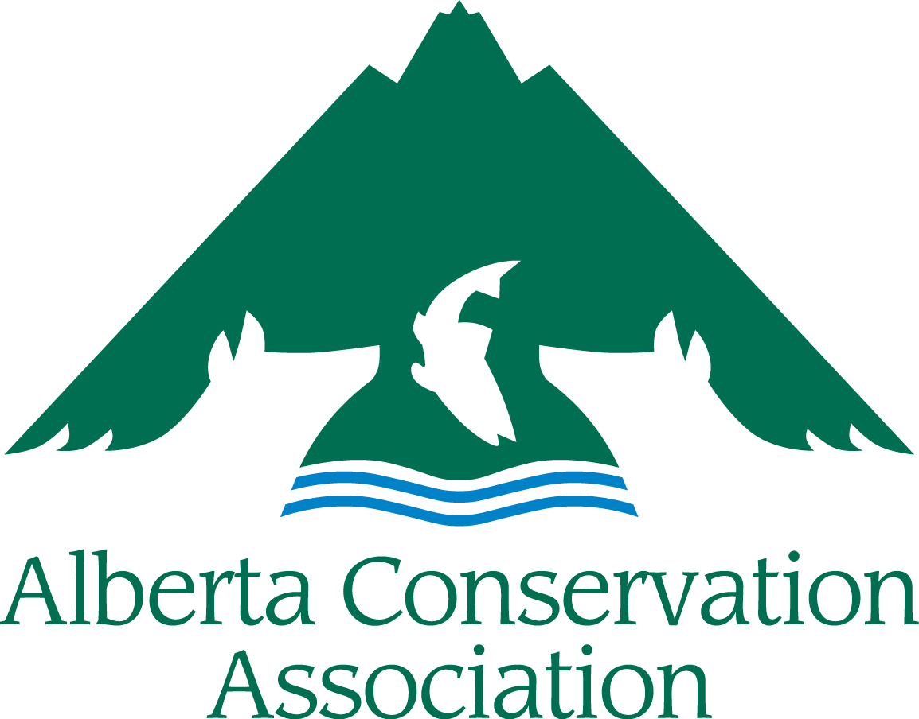
Minister’s Special Licence
Raffle Funds Grants
Application Form
2024 – 2025

BEFORE YOU SUBMIT, PLEASE MAKE SURE:
- You read the Minister’s Special Licence Raffle Funds Grants (MSL RFG) Submission Guidelines for 2024-25.
- Your application is complete. Incomplete applications will be returned to the applicant. All sections must be filled in.
- Your application is NOT longer than the 8-page limit (excluding the cover page). Applications over the page limit will be returned to the applicant for reformatting.
- Your application is a legible font size (i.e., nothing smaller than Arial 10).

Please submit your digital application to amy.mackinven@ab-conservation.com
Applications accepted from December 1, 2023, to January 18, 2024
(NO later than 16:30 local time on Thursday, January 18, 2024)

IMPORTANT NOTICE: upon receiving your application, we will send you an acknowledgment receipt by e-mail or telephone within five business days. It is your responsibility to contact the ACA Grants Coordinator if you have not received acknowledgement of receipt, as the application may not have been received in good order.

APPLICANT INFORMATION
Principal Applicant’s Name
Organization
Mailing Address
Email Address
Telephone Number
Project Manager/Co-applicant(s)
(if different than applicant)
Not-for-profit Business Number (if applicable)
AGLC Registration No.
PROJECT INFORMATION
Project Title
Project Location
Project Duration | Start date dd/mm/yyyy |  | End date dd/mm/yyyy
Project Summary (Please include a brief description of your project containing the objectives, activities, and project deliverables; maximum 250 words)

Amount requested from MSL RFG
(in Canadian dollars)

Has this project received financial or administrative support from Minister’s Special Licence (MSL) grants in the past? If yes, list the grants and highlight the results of the work previously supported by the MSL. How does the present funding request build on that work?
Long Term Requirements (Is the project ongoing? Does this project require subsequent funding to reach project objectives? If applicable, explain how this project will continue after being funded by MSL RGF.)
PROJECT DESCRIPTION
Project Background/Project Rationale

Project Objectives (Clearly state the project’s specific objectives, i.e., what is your project trying to achieve?)

Project Activities (How and when are you going to achieve the above objectives?)

Deliverables (List anticipated products and completion dates resulting from your project, including reports, videos, publications, structures built, promotional material, number of events with dates and locations, number of educated participants/campers, number of people reached, kilometres of wildlife-friendly fencing, hectares sustainably managed, etc.)

List Project Partners (Project Partners must be aware they are listed here and be involved with this specific project. Do not include organization partners if they are not involved with the project.)
LINK WITH THE MSL RFG FUNDING PRORITIES
State how this project meets the Funding Priorities as outlined in Section 3 of the Submission Guidelines. Select all the Funding Priorities that your project addresses and discuss in the text box below how your proposed project helps further the Funding Priorities.

Funding Priority 1 ☐ Funding Priority 4 ☐ Funding Priority 7 ☐
Funding Priority 2 ☐ Funding Priority 5 ☐ Funding Priority 8 ☐
Funding Priority 3 ☐ Funding Priority 6 ☐

Does your project focus on any of the following species? Select all that apply:
Bighorn sheep ☐ Mule deer ☐
Elk ☐ Pronghorn ☐
Moose ☐ Turkey ☐

Explain how your project will benefit hunters in Alberta (maximum of 250 words)
BUDGET
Category | Description | Amount Requested from MSL RFG | Confirmed Partner Funding | In Kind Support | Total
Materials & Supplies
Equipment
Salaries & Wages
Contract Services
Travel
Honorariums
Other
TOTAL COSTS
Please Note: MSL RFG do not cover overhead costs. See Submission Guidelines Section 4 Budget Notes for more information.

PROJECT BUDGET COMMENTARY
BUDGET COMMENTARY:
Provide breakdown of salary costs/honoraria (number of staff, rate, etc.), equipment (unit cost, etc). Include other details that may assist with the evaluation of your budget. You don’t need to send quotes.

Summarize any Partner Funding Dollars (Please indicate if the partner funds are confirmed or pending approval. Confirmed partner funding should be listed in the budget. If there is no partner funding, please explain why not.):

Summarize any Public Involvement in the Project (Such as in-kind support, number of volunteers, etc.):
PROJECT COMMUNICATION
How will MSL RFG be recognized for its funding support?

How will you share the results of the project with others?

LICENCES & APPROVALS
I have all the proper licences and approvals required to carry out the project and have complied with all the requirements of my organization. YES ☐ NO ☐

If you ticked NO above, please explain how will you obtain them in time to carry out this project?

Please Note: Successful applicants will be expected to follow the ACA Cooperative Project Agreement. In applying to the MSL RFG program, you are agreeing to use ACA’s Cooperative Project Agreement. A copy of the Cooperative Project Agreement can be found on Appendix 2 of the MSL RFG Submission Guidelines document.

