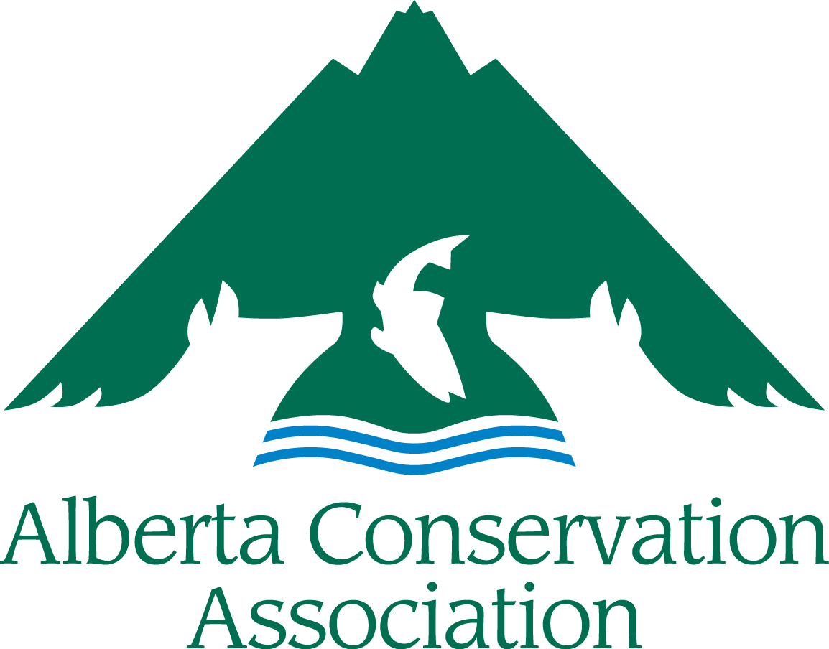
ACA Conservation, Community
and Education Grants Application Form
2020 – 2021

Small Grant
(for requests of $3,000 or less)

Please submit your digital application to amy.mackinven@ab-conservation.com
Applications accepted from January 1st to 24th 2020
(NO later than 16:30 local time Friday, January 24th, 2020)

INCOMPLETE APPLICATIONS WILL BE RETURNED TO THE APPLICANT. ALL SECTIONS MUST BE FILLED IN.

Hard copies also accepted:
Alberta Conservation Association
#101, 9 Chippewa Rd,
Sherwood Park, AB,
Canada, T8A 6J7
Toll Free: 1.877.722.4323
Facsimile: 780.464.0990

A maximum page limit of 8 pages has been introduced for ACA Conservation, Community and Education Grant applications (excluding the cover page, please use a legible font size, i.e. nothing smaller than Arial 9)

APPLICANT INFORMATION
Principal Applicants Name
Organization
Mailing Address
Email Address
Telephone Number
Not-for-profit Business Number (if applicable)
PROJECT INFORMATION
Project Title
Project Location
(please append map, if available)
Project Duration | Start date dd/mm/yyyy |  | End date dd/mm/yyyy
Project Summary (Please include a brief description of your project containing the objectives, activities and project deliverables. Maximum 250 words)

Amount Requested from ACA (in CDN Dollars)

Has this project received financial or administrative support from the ACA in the past? (If yes, please highlight the results of the work previously supported by the ACA. How does the present funding request build on that work? Note: It is important to demonstrate evidence of progress if this is a request for repeat funding.)
PROJECT DESCRIPTION
Project Objectives: (Clearly state the specific objectives, i.e. what is your project trying to achieve?)
Project Activities (What are you going to do to achieve the above objectives?):
Deliverables: (List anticipated products and completion dates resulting from your project, including reports, videos, publications, structures built, promotional material, # of events with dates and locations, # of educated participants/campers, # of people reached, km of wildlife friendly fencing, ha sustainably managed, etc.).

LINK WITH ACA
State how this project meets the ACA Mission and the Funding Priorities as outlined in Section 3 of the Project Submission Guidelines (Please use the Funding Priority Number so it is clear):
Explain how your project will benefit hunters, anglers or trappers in Alberta (Maximum of 250 words):
PROJECT BUDGET
BUDGET:
Provide details on your budget, such as salaries and wages (include the rate), equipment, materials and supplies, etc. Please list financial contributions by participants/campers (are participants paying something to attend the camp, workshop, or other event?) (please see the Guidelines Section 4 Budget Notes for more information).

BUDGET COMMENTARY:
Provide any other details, including any public involvement and in-kind contributions, which may assist with the evaluation of your budget.

PROJECT COMMUNICATION
How will ACA be recognized for its funding support?
How will you share the results of the project with others?

Please Note: Successful applicants will be expected to follow the ACA Cooperative Project Agreement. In applying to the ACA Conservation, Community and Education Grants, you are agreeing to use ACA’s Cooperative Project Agreement.
I have all the proper licenses and approvals required to carry out the project and have complied with all the requirements of my organization. YES NO

